**Journal of Experience: Working with XEROX IT Pvt. Ltd.**

Reported by: Bishal Lamichhane, CEO

Address: Kathmandu

Date: 2023/08/20

**Introduction:**

I had the honor of participating in a transformative project as a team member of XEROX IT Pvt. Ltd. assigned to the project for developing a management analytical system at The Arena Group. The project chronology, my experience, and the learning’s from this joint adventure are all summarized in this report.

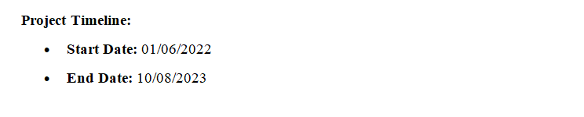

**Journal of Experience:**

**Initial Phase:**

The needs and difficulties faced by The Arena Group were thoroughly understood before the project got under way. To ensure a full understanding of their operations, procedures, and strategic goals, we had in-depth conversations and interactions with their personnel. This phase, which lasted about 01/08/2023, set the groundwork for modifying the management analytical system to meet their particular needs.

**Development and Integration:**

After doing needs analysis, our team started working on developing and integrating the suggested system. This stage covered the entire 6 month and necessitated painstaking design, development, and integration activities. Our team's collaborative talks helped to guarantee that the project's objectives were met and that we seamlessly integrated with their existing infrastructure.

**User Training and on boarding:**

We entered the user training and on boarding phase, which lasted 6 month, as the system's completion drew near. The Arena Group's staff was able to become skilled in using the system's capabilities, UI, and analytics tools by holding thorough training sessions. To ensure a quick learning curve for the users throughout this phase, excellent communication and hands-on support were prominent.

**Project Conclusion:**

We are now on August 28, 2023, after the project's successful deployment of the management analytical system. It was tremendously satisfying to watch the system in action and see how the decision-making and resource allocation procedures at The Arena Group changed right away. The Arena Group and XEROX IT Pvt. Ltd.'s productive partnership validated the worth of our solution and its ability to promote long-term growth.

**Insights Gained:**

Working on this project gave me vital knowledge about the value of customized solutions and productive teamwork. The encounter emphasized how crucial it is to comprehend the particular requirements and difficulties of the client in order to create a solution that melds into their business processes.

Observing the change brought about by data-driven decision-making also emphasized the capability of technology to spur development and innovation. The project also demonstrated the need of ongoing communication and flexibility in ensuring that the solution complied with The Arena Group's changing needs.

**Conclusion:**

It has been a rewarding experience to work with XEROX IT Pvt. Ltd. on The Arena Group's management analytical system deployment. A successful solution that supports data-driven decision-making was produced as a consequence of thorough planning, development, and smooth cooperation throughout the project's schedule. My faith in the ability of technology to effect positive change and promote corporate growth has been reinforced by this experience.

Top of Form